Adding cameras to layout/ saving layout

Click the server drop down to reveal the cameras

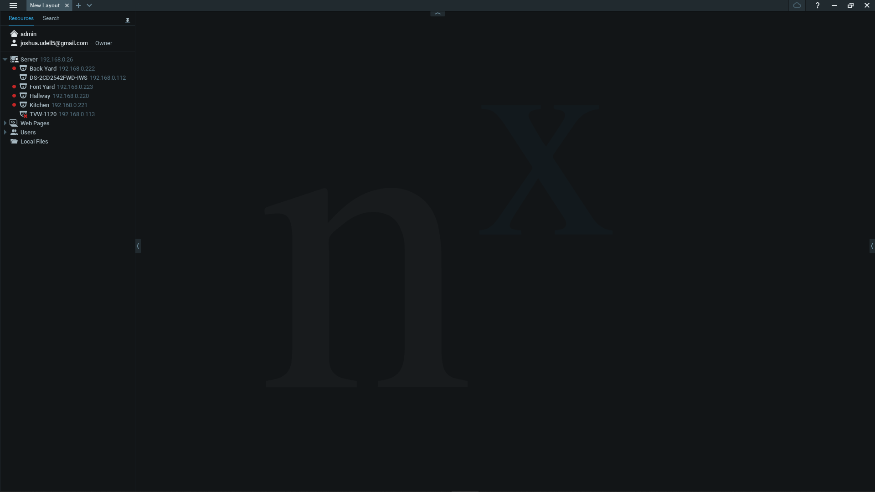

Double click the cameras to add them to the layout

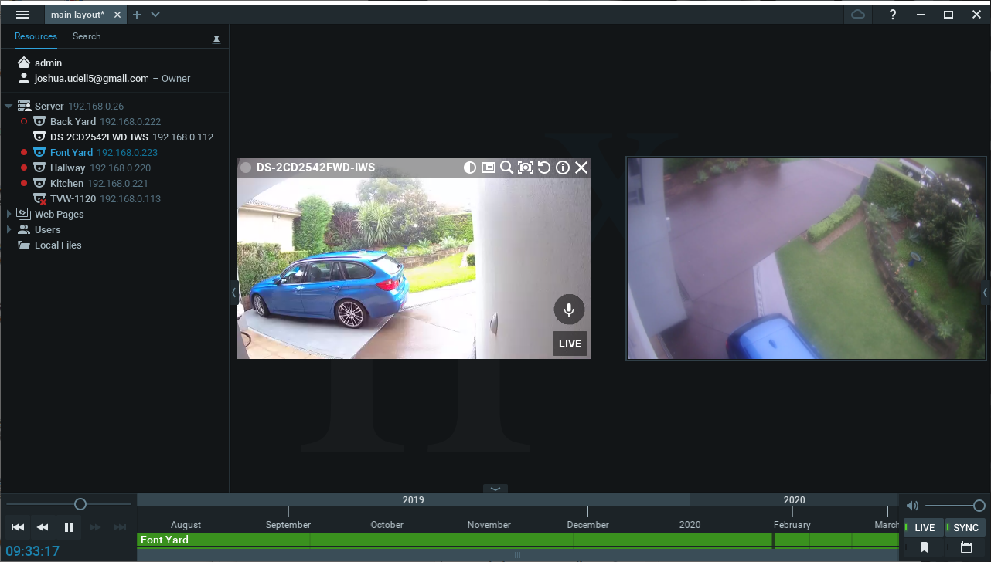

You can drag the images around to change the position of them 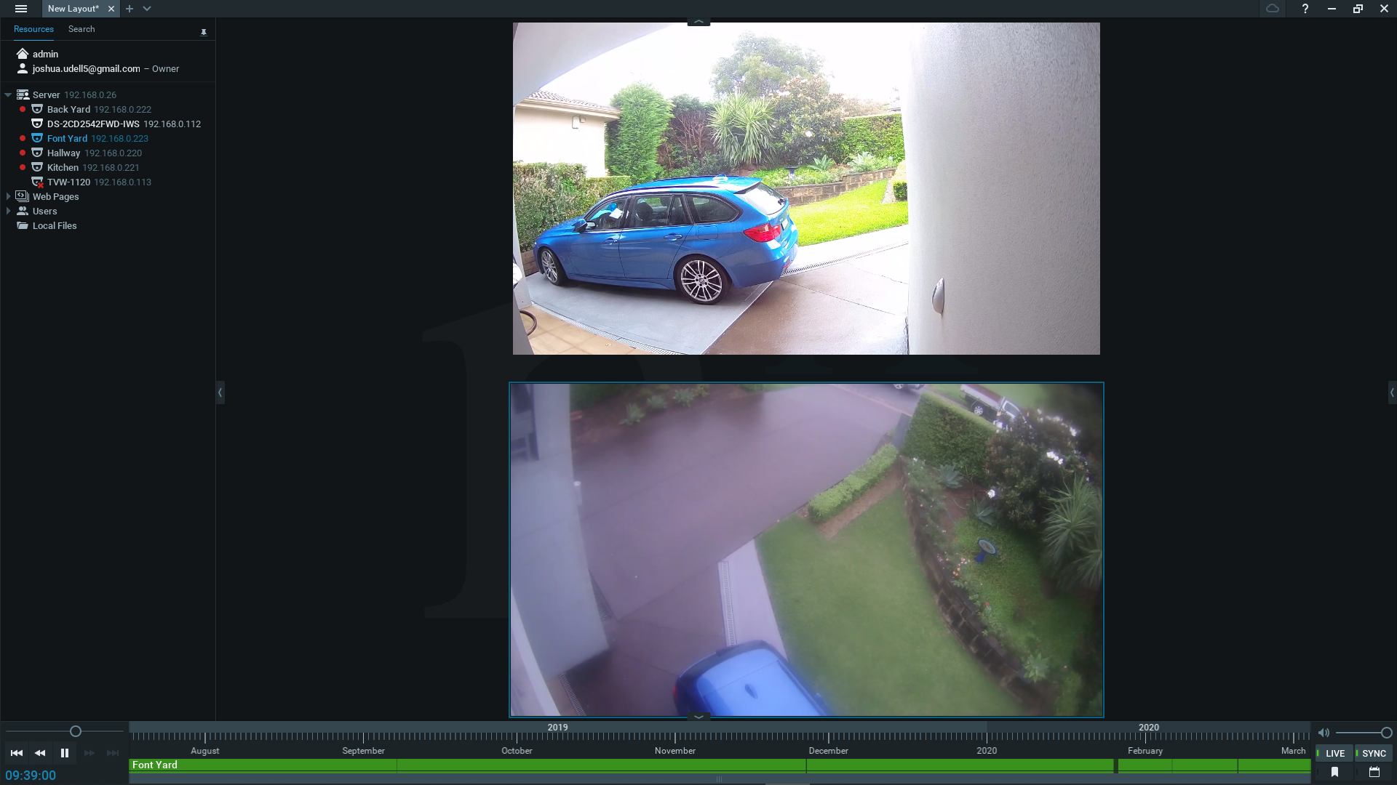

You can make them smaller or bigger buy holding the corners and dragging

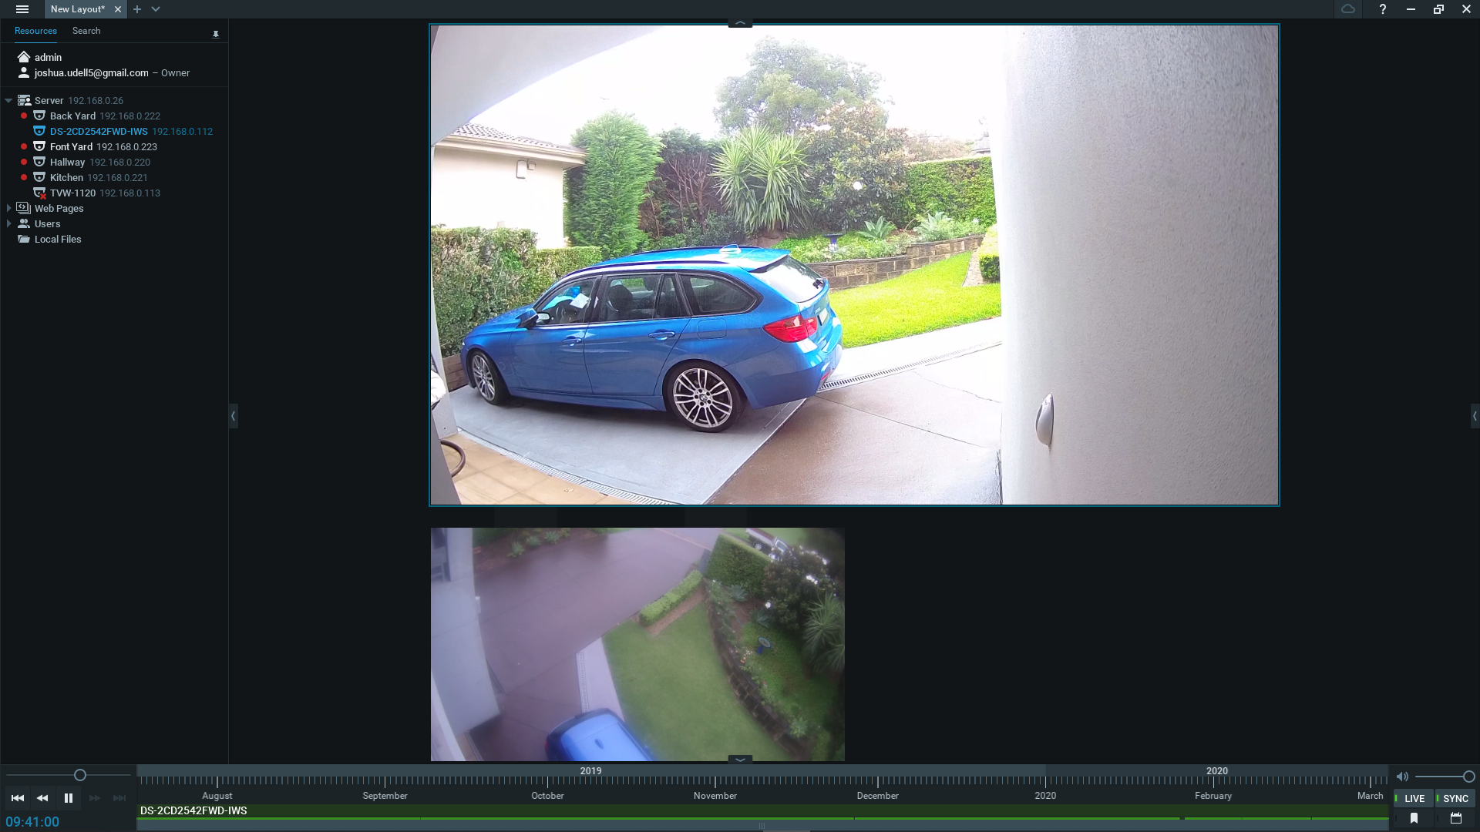

Once you are happy with you lay out

-right click on “New layout” (at the top left of the screen)

- then click “Save layout As” and name it something meaningful

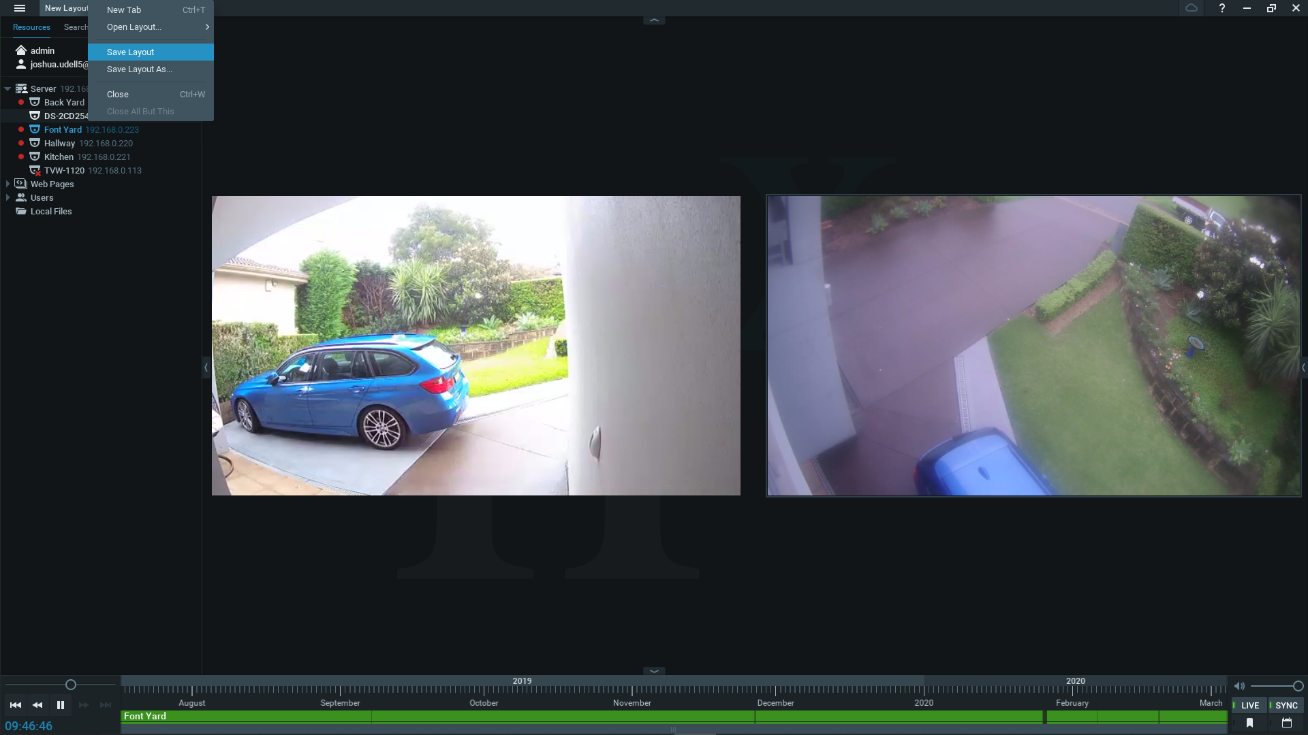

Reviewing footage

At the bottom there the is the play back bar

Green = playback speed

Orange = video control buttons

Blue = timeline

Red = volume

Yellow = live / sync buttons

With you mouse hovered over the timeline you can change the range of time by scrolling

When you have found your time you can click on the time line and then press play to review the footage

You can move the slider to change the playback speed

Exporting video

Using “Ctrl” click on the cameras you what to export.

Then on the timeline click on the starting point of the footage you want then hold and drag to select the rest of the footage

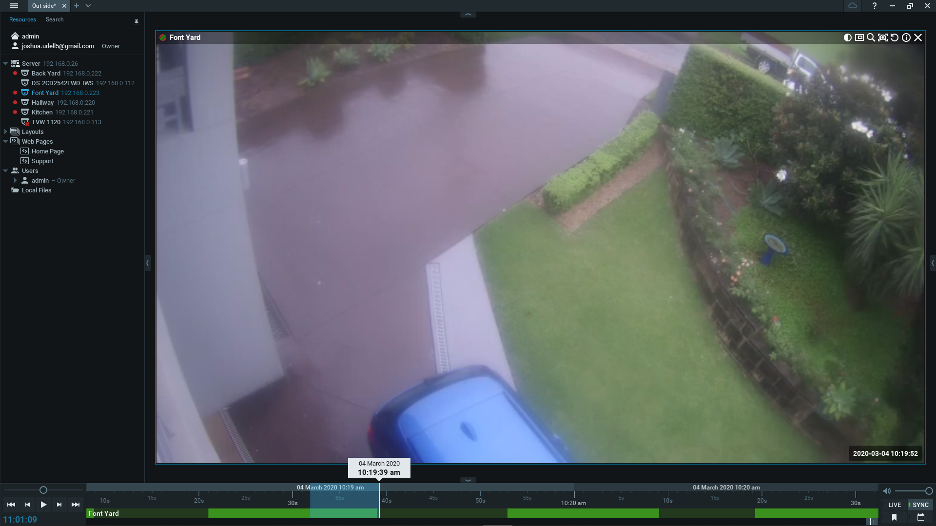

Then right click on the highlighted area and click “export video”

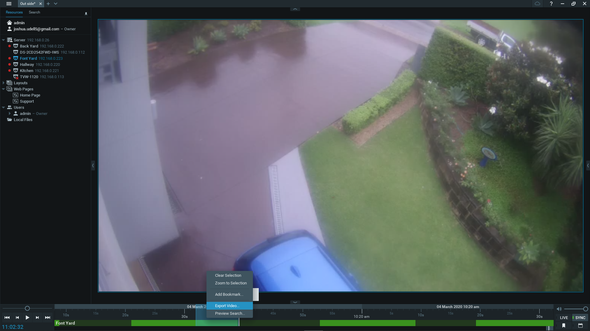

Click add a time stamp

And chose and file location and name for the video

Click export

